public class Main {  
  
 static double calcToll(int hour, boolean isMorning, boolean isWeekend) {  
 // Validate hour  
 if (hour < 0 || hour > 23) {  
 System.*out*.println("Oops! That's not a valid hour.");  
 return -1;  
 }  
  
 // Weekend tolls  
 if (isWeekend) {  
 if (hour < 7) {  
 return 6.05;  
 } else if (hour >= 7 && hour < 20) {  
 return 7.15;  
 } else {  
 return 6.10;  
 }  
 }  
 // Weekday tolls  
 else {  
 if (hour < 7) {  
 return 6.15;  
 } else if (hour >= 7 && hour < 10) {  
 return 7.95;  
 } else if (hour >= 10 && hour < 15) {  
 return 6.90;  
 } else if (hour >= 15 && hour < 20) {  
 return 8.95;  
 } else {  
 return 6.40;  
 }  
 }  
 }  
  
 public static void main(String[] args) {  
 System.*out*.println(*calcToll*(8, true, false)); // 7.95 (weekday morning)  
 System.*out*.println(*calcToll*(13, false, false)); // 6.90 (weekday afternoon)  
 System.*out*.println(*calcToll*(15, false, true)); // 7.15 (weekend afternoon)  
 System.*out*.println(*calcToll*(5, true, true)); // 6.05 (weekend early morning)  
 System.*out*.println(*calcToll*(25, true, false)); // invalid hour  
 }  
}

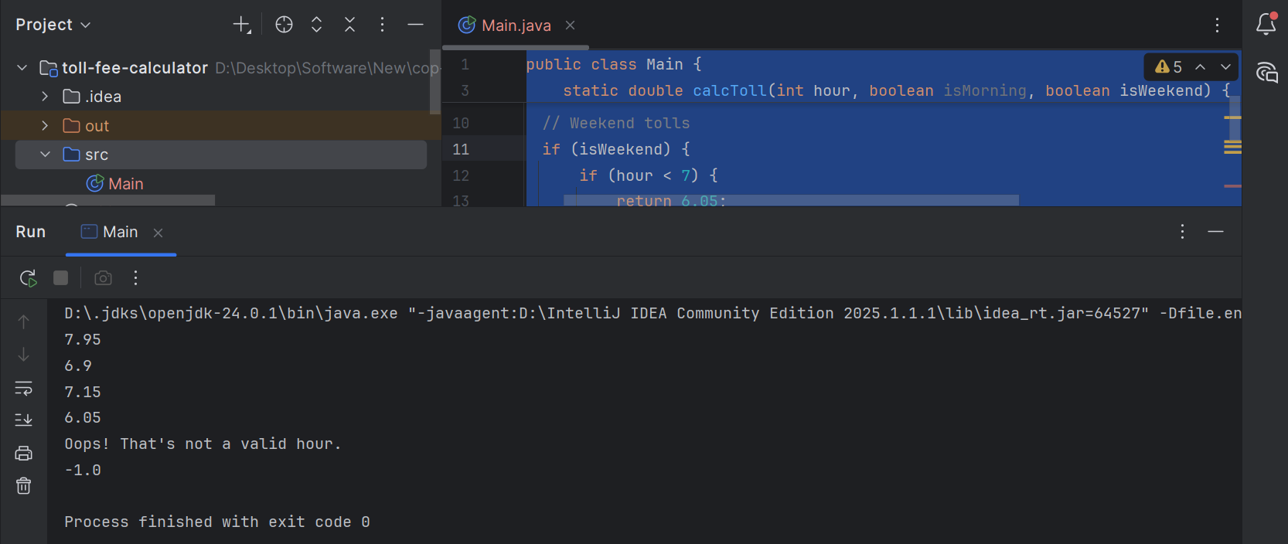

**IMPORTANT NOTE:**

Although the assignment requires the method signature to include isMorning, this parameter is unnecessary. I didn’t use isMorning because the hour (0–23) already indicates the time of day. Since the toll fees depend solely on hour ranges, isMorning is redundant. Using hour alone is enough to calculate the correct fee.